Website for “Spartan Stones”

Capstone Project

<www.spartanstones.com>

Maulik Mukesh Patel

University of North Alabama

Author Note

Maulik Mukesh Patel, Department of Interdisciplinary and Professional Studies,

University of North Alabama

Mailing Address: 1011 Midland Avenue, Apartment 7H, Muscle Shoals, Alabama, 35661

Contact: mpatel59@una.edu

Submitted to: Dr. Craig Robertson (Director, Division of Professional, Interdisciplinary)

ABSTRACT

This capstone project focuses on creating a website for a marble and granite manufacturing company called “Spartan Stones” located at four different offices. This research aims to develop and design a basic 5-page website such that all the web pages are compatible with the electronic gadgets as well as which can help the business to expand its reach. This project has a direct quotation facility through email as per the requested criteria by the customer, it could potentially add an administrative panel in the future to the client side, so an inventory of stock from the inventory management software can be directly linked to the website for each of the four offices tied to this business.

*Keywords:* develop, design, website, inventory.

Table of Contents

**Cover Page1**

**Abstract2**

**Table of Contents3**

**Introduction and Statement of Problem4**

**Justification of the Study 5**

Requirement Assessment5

Intended Customers5

Relations between the requirements and goal of website 5

**Literature Review6**

Proposed Recommendations 8

Implementation of the Recommendations9

Evaluation and Follow-Up 16

**Conclusion17**

INTRODUCTION AND STATEMENT OF PROBLEM

The purpose of developing and designing a website is to provide exposure as well as to expand the client’s business. In this digital 21st century world people’s needs, and desires have changed drastically almost eliminating the traditional way of shopping where an individual would go to a shop or store regularly to buy products. The new trend that is observed is consumers want to see everything digitally at their fingertips. “What people see is what sells” so, to attract customers, one needs to have digital representation of the products. This Capstone project aims to develop a website that helps the client to increase their business and to attract a large number or crowd by going online.

JUSTIFICATION OF THE STUDY

* Requirement Assessment: To determine the needs for the website the author had a discussion with the client and administrated a small survey to figure out actual requirements regarding what they would like the website to look like. The author also had a discussion with some regular customers regarding their expectations that would help the client to expand and gain more business. Some of the requirements that the client’s customers wanted were digital images of the products and the request for price quotes of the specific products and size. The client’s requirements were to go digital where customers can send an inquiry form that they can view digitally and respond as fast as possible while maintain a track on inventory of stock for all three different locations.
* Intended Customers: The targeted audience for this website is nearby cities and states for expansion of the business. Currently the business has three different office locations in the North Alabama region and the client wants to cover the south part of the state as well as some nearby states for an initial stage of business. Later, if the business grows then the target area may be further increased.
* Relations between the requirements and goal of website: Ideally anyone from anywhere who browses the website will be able to view the following things:
* Information regarding the history behind “Spartan Stones”
* Products that are manufactured and sold with the small description.
* Quotation inquiry form as well as contact information.
* Products inventory.

LITERATURE REVIEW

Developing a good website involves more than writing the code. Many more things are to be considered. Websites are the medium of communication that provides full information regarding an organization. The information and the control provided must be structured as well as analyzed to convey its actual meaning. This capstone project will provide information regarding the theories, principles and recommendation for website development.

* There are some important questions that should be considered as a strategic plan at an initial stage,
  + What is the aim of the organization?
  + What are the difficulties faced by the organization to reach customers?
  + What are the questions and requirements of the customers?
  + What will the benefits be after creating a website?
* Important factors that should be kept in mind to make a website successful in different areas of business:
  + Plan of action: First, create a brochure that will provide an example of the website and how it will look and how the content be written in it. The client can review this so there are no problems regarding the color and structure once you start creating.
  + Project Management: a website should be managed as a single customer interface (user interface) project rather than following the old traditional corporate process.
  + Architecture: the design and layout of the website must be same as the organization is organized. Along with this, the site ought to be organized to reflect the clients' assignments and their perspectives of the data space
  + Content Writing: the way website presents the content(text) written in it describes the structure of the organization. So, to make an impact of uniqueness and to attract more clients content writing must be accurately written and summarized.
* A website that successfully maintain all the following goals is termed as successful website:
  + The purpose and description of the website and its products should be clearly mentioned.
  + The design should be purposeful.
  + The website should consider both quantitative and qualitative responses.
  + Gives customers a chance to follow up on reactions and work together.
  + Provides information and testimonials of the clients.

PROPOSED RECOMMENDATIONS

After having a conversation with the client, the author suggested some changes and outcomes that may help the business to grow and expand due to the digitalization of the business these suggestions are as follows:

* The customers may get all the information about the product at their fingertip.
* Free quote of the product available within 24 hours by email.
* Easy to contact and find the nearest location of the factory.
* Not only the regular customers but many more new customers may also be attracted by viewing the content and type of products.
* The design of the website is compatible with all the devices such as desktops, laptops, mobile phones, tablets and iPad.
* The client can maintain the stock for all different locations without visiting all the three locations.

IMPLEMENTATION OF THE RECOMMENDATIONS

* Old version of Spartan Stone website.

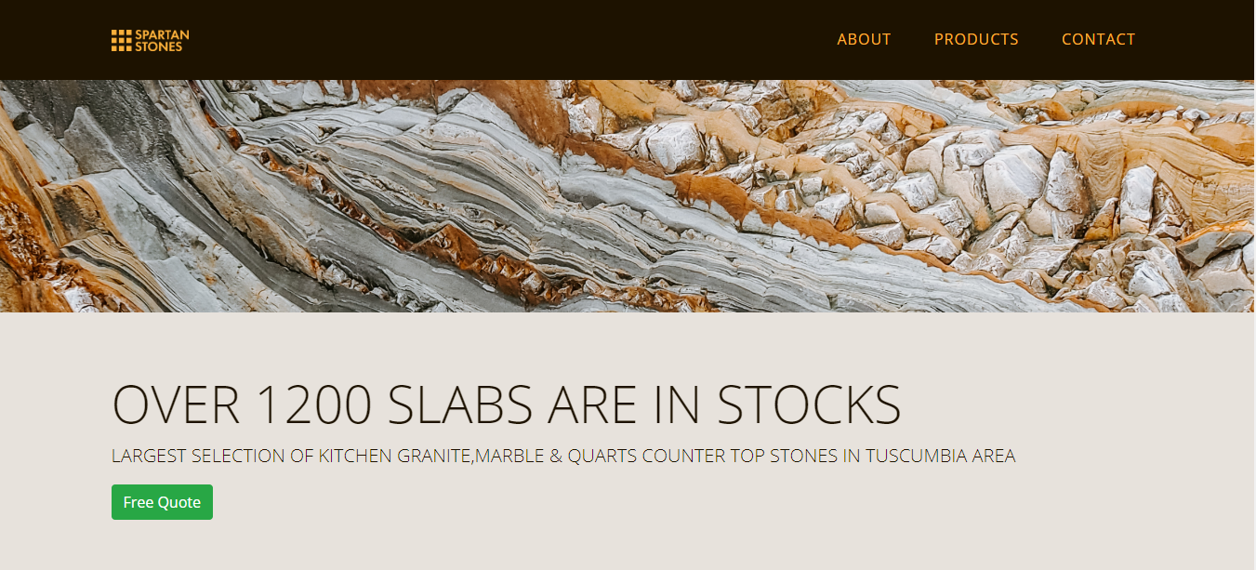

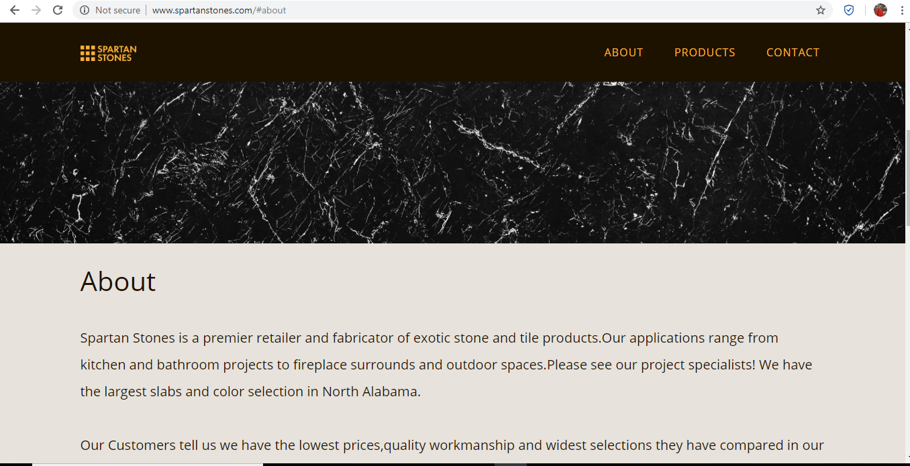

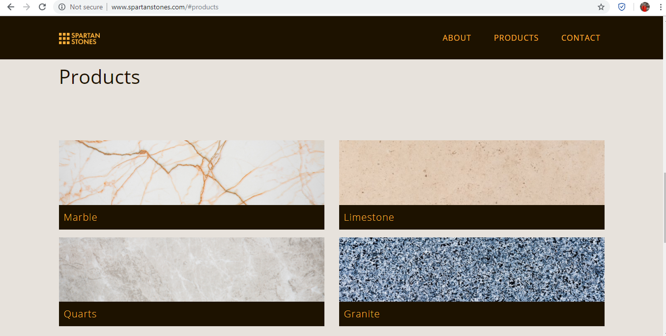

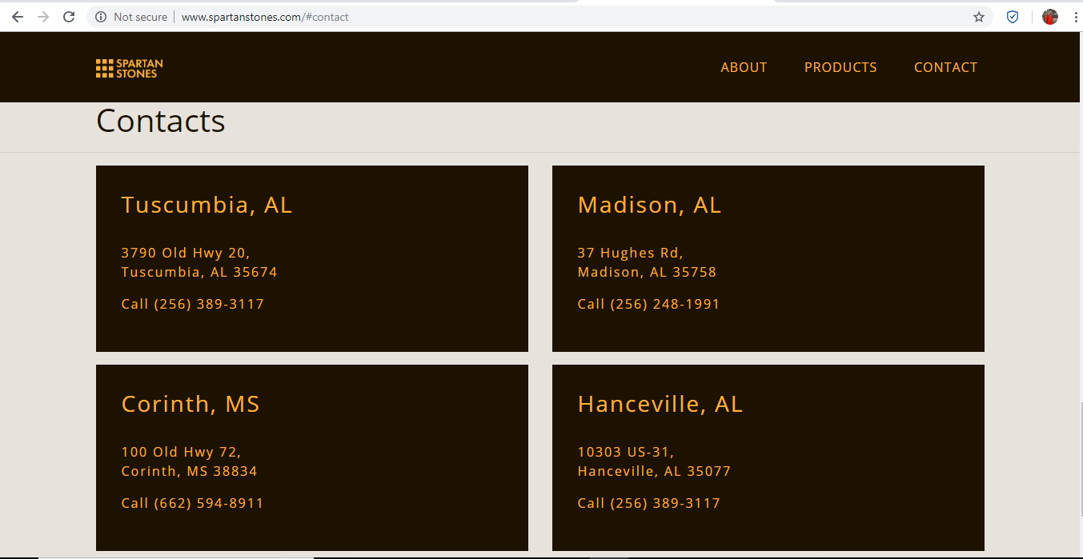

* Newly designed and developed website of Spartan Stones.

Home Page: Mainly the home page has all the information about the company. The page starts with the header part consisting of logo and contact details for the main office, followed by the navigation bar consisting of the different tabs for different pages and the inquiry tab. Then comes the image of the company’s best product which is followed by the small description of the company, then comes the products display and moving down there are the locations and addresses of all four offices. At the end there is footer which has the link to different social media accounts of the company.

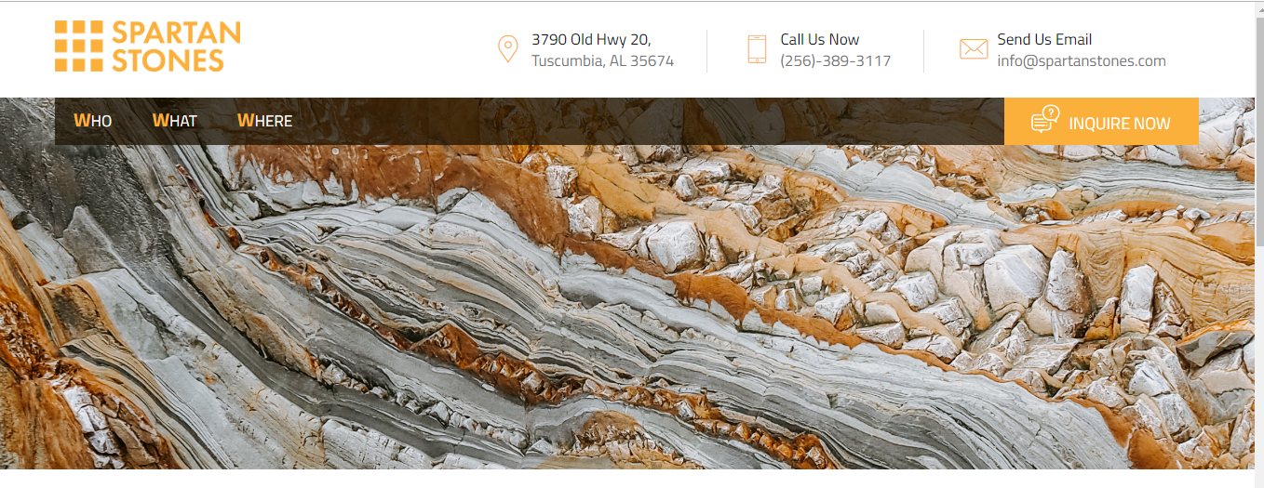

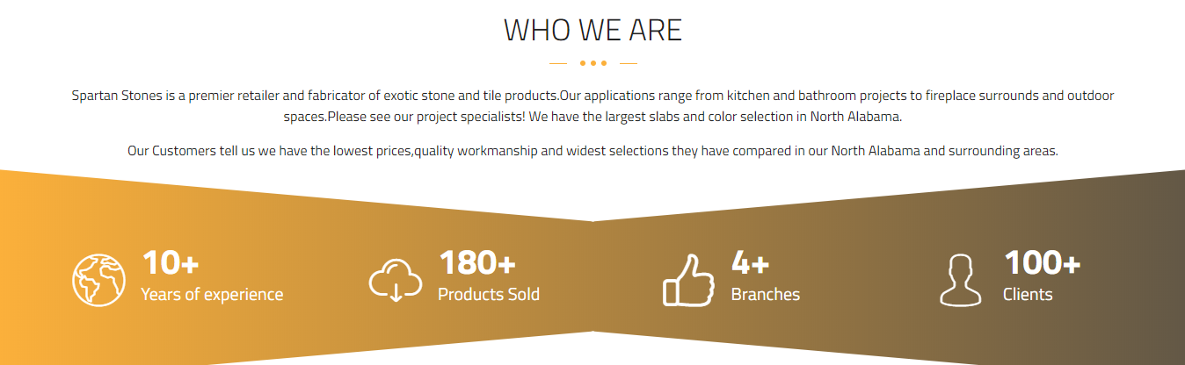

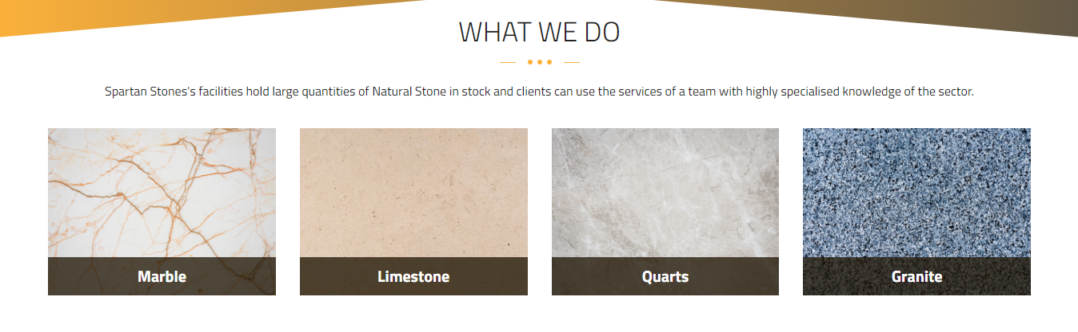

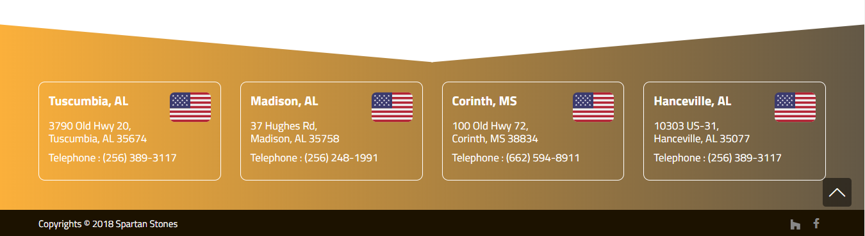

About US: “WHO” this web page gives the views to know the history and the development phases of the company. Details regarding the variety of products and the evaluation of the company from one destination to four different destinations.

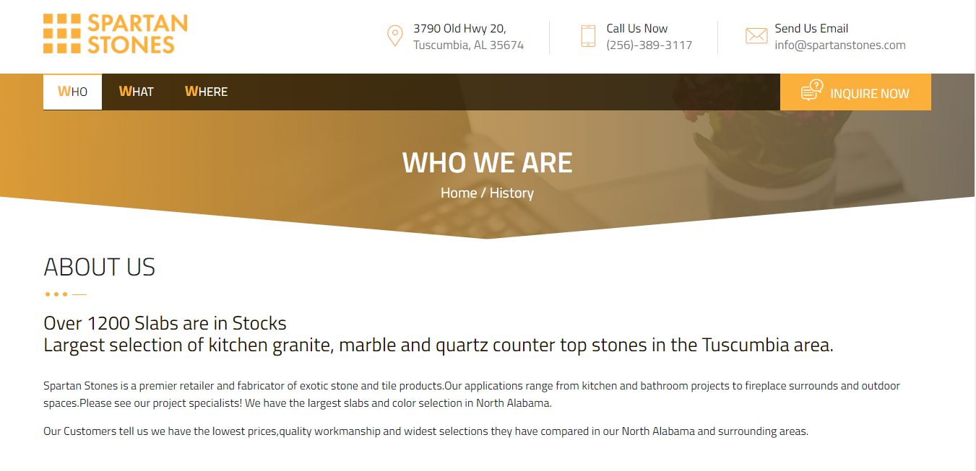

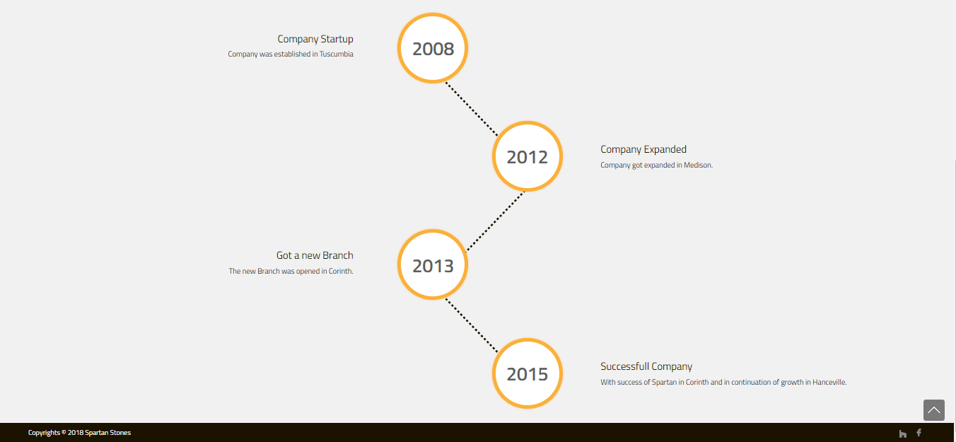

Products: “WHAT” this web page consists of the details and the pictures of the products. As per client’s customer requirements this page has been created with the pictures of four different stone that are mainly manufactured by Spartan Stones and the different carvings created from those four products used in different parts of construction business.

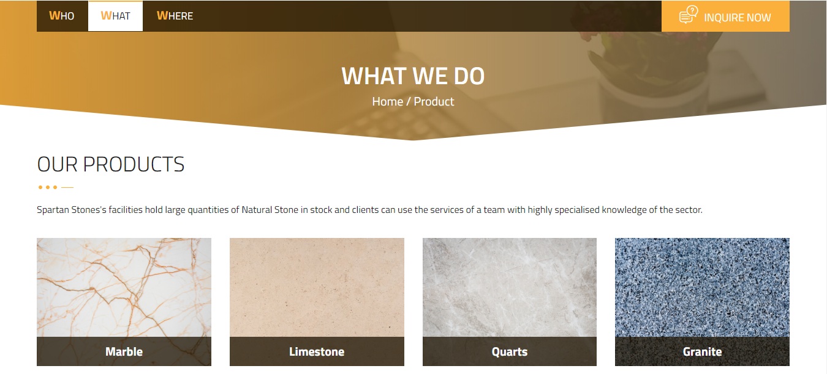

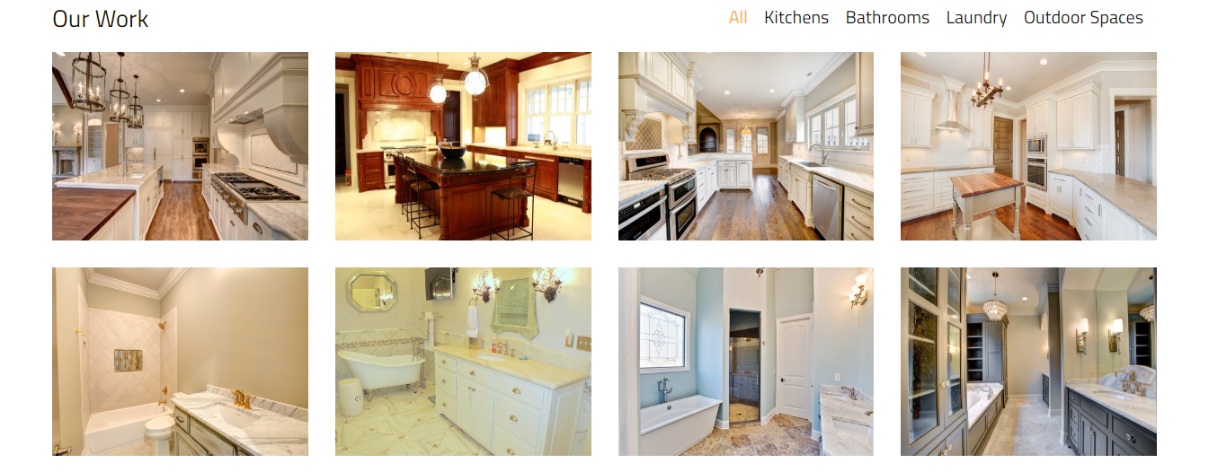

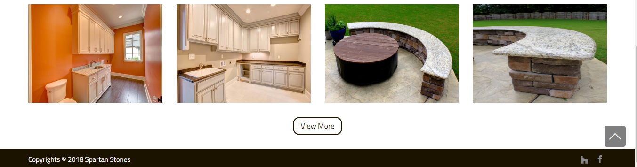

Contact US: “WHERE” this web page has the location information of all four Spartan Stones facilities with their contact numbers so that the customers and can easily access it as per their requirements.



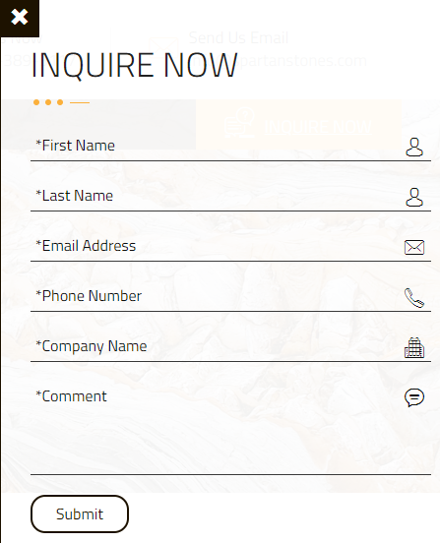Inquire Now: This tab on the top right-hand side of each page will open inquiry form for the customers wanting to get the actual quotation of the product as per the measurements stated by them. Here the user must fill the form and by clicking on submit button at the end the form will be directly send to the “Spartan Stones” by email so that they can respond and have follow-up.

EVALUATION AND FOLLOW-UP

The first phase of the website is ready which has newly designed and developed webpages as per the client’s requirements as well as the email facilities for the quotation request by the client’s customers. The second phase in progress is getting the feedback and testimonials from the client and the client’s customers regarding the website changes. The third stage of the website is to make the necessary changes as per the client’s feedback and working on testimonials.

The future recommendation of this website is to develop the inventory management software that links with the website and gives the users login facilities and stores their data to offer discounts to regular customers.

CONCLUSION

Having developed a webpage before in undergraduate studies, I was able to have a strong base of creating the webpages and then combining them to a single website. However, I had to take some support from faculties and friends to get the things going. By developing this website, I did gain a lot of knowledge as this was my first project outside my home country working. I did face a number of issues like the language barrier, making the client understand the technology and the uses of it to make his as well as the customers work easy and to expand the business.

This website has “WHO” tab that will give the brief history regarding the company,” “WHAT” will give all the products information, “WHERE” will give all the locations and phone details; “INQUIRE NOW” is a form that will help client’s customers to request the quotation of the product as per their measurements and get the response for that within 24 business hours.

I am thankful to Spartan Stones for providing me this opportunity that will help me to build my career as a web developer. The most amazing thing working on this project was contacting the client’s customers for their views and requirements that they would like to see. I am excited to continue my work with Spartan Stones for the second phase of developing the inventory management software and linking it to the website.